GGR272 Assignment 2

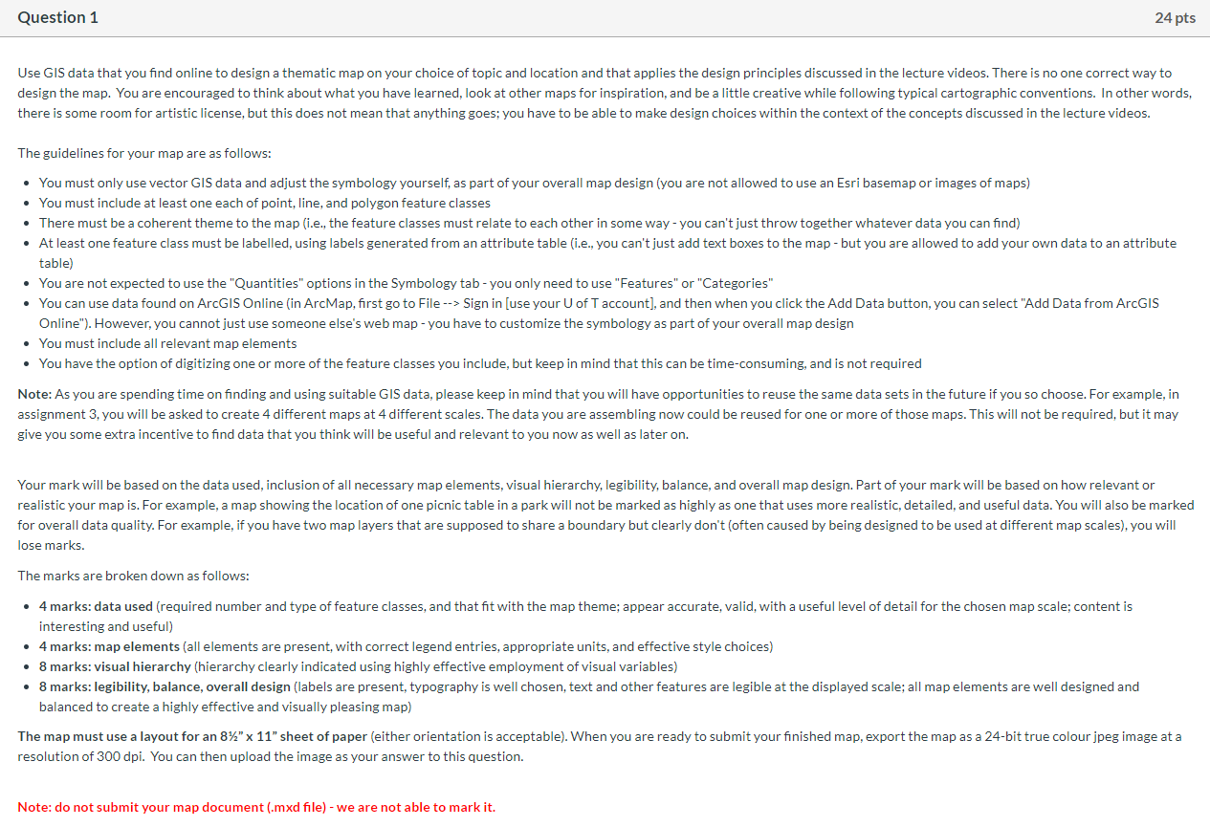

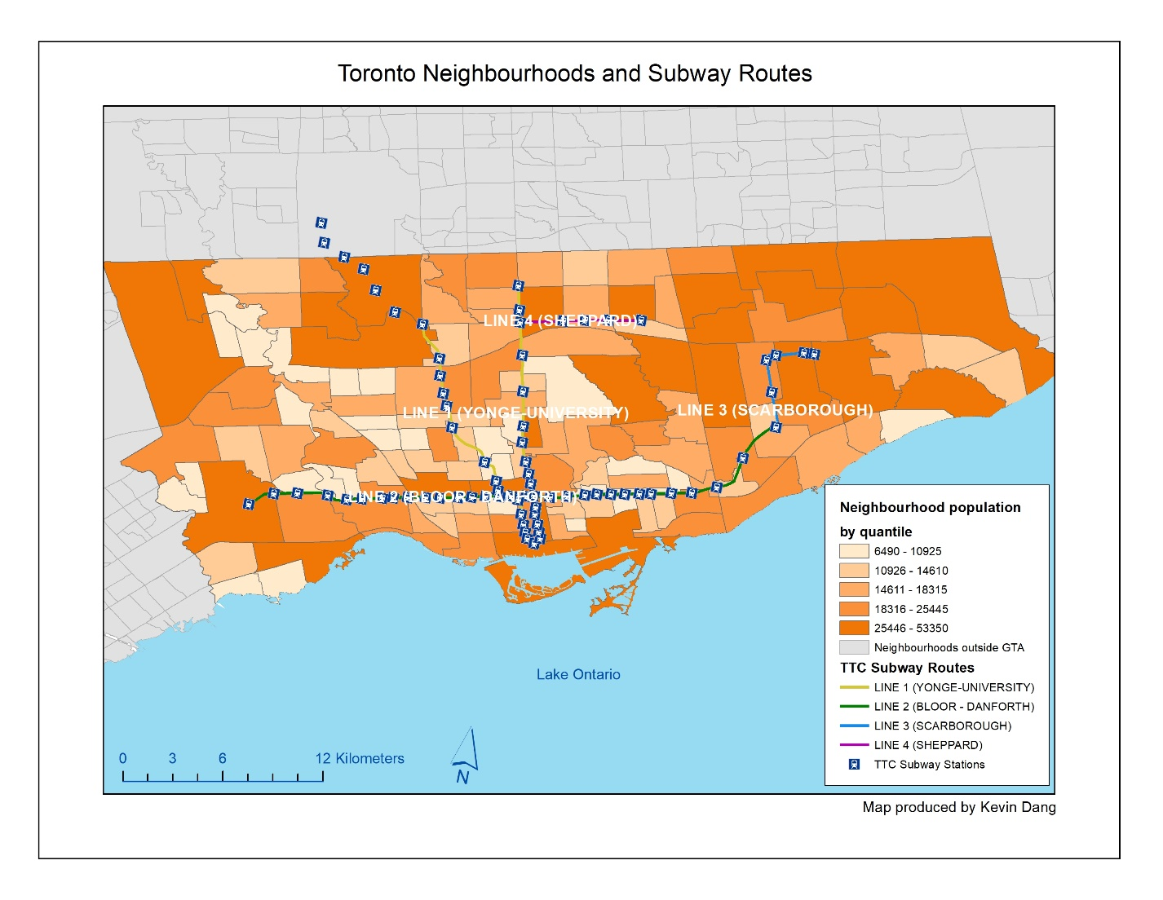

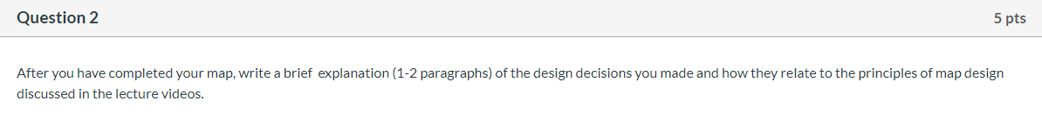

On my map I included a Title at the top to make it one of the first things people will read. There’s also a border which separates the map from the title, and a frame around the title as well. The main focus of the map (the city of Toronto) is centered so that it stands out from the rest, while there is also a colour scheme which sorts the neighbourhood population from lowest to highest quantile. The non-relevant neighbourhoods are coloured grey, the legend is in the corner with a white background and the scale and north arrow are in the other corner, blending with the lake background. This is based on the principles of visual hierarchy as we want to viewer to focus on the important aspects of the map. In terms of labelling, the TTC Subway Routes have been labelled horizontally as that is the ideal way to read, and the font is in white to make it more visible compared to black which is incredibly hard to read on this map. I also removed Lake Ontario from the legend and labelled it to blend in with the background as it is not meant to be important to the map, but rather it is there to just make it look like the city is not floating in white space.

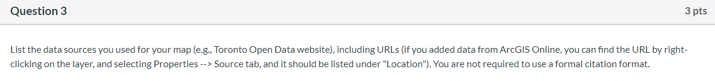

City of Toronto Open Data - Data Catalogue: <https://services.arcgis.com:443/As5CFN3ThbQpy8Ph/arcgis/rest/services/Toronto_Neighbourhoods/FeatureServer>

Statistics Canada: <https://services.arcgis.com/6iGx1Dq91oKtcE7x/arcgis/rest/services/Census_Tracts_WEB/FeatureServer>

Esri Inc.: <https://services.arcgis.com/As5CFN3ThbQpy8Ph/arcgis/rest/services/TorontoSubwayRoutes/FeatureServer>

Esri Inc.: <https://services.arcgis.com/As5CFN3ThbQpy8Ph/arcgis/rest/services/Toronto_Subway_Stations/FeatureServer>

University of Michigan: <https://services1.arcgis.com/4ezfu5dIwH83BUNL/arcgis/rest/services/great_lakes/FeatureServer>

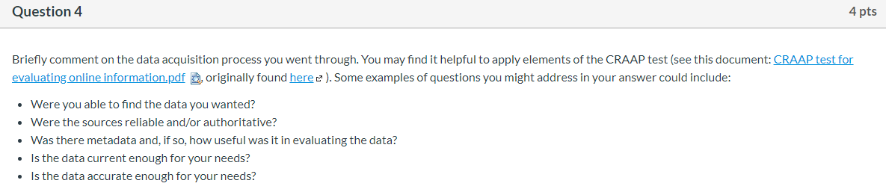

The acquired data is for the most part what I desired, although there was a minor exception. While the subway stations data is completely up to date, the subway routes data is missing the line 1 extension that was added at the end of 2017. This is quite surprising because both the subway stations and the subway routes data belong to Esri Canada Education, and the data was updated in 2019. The sources were quite reliable, since the sources included City of Toronto Open Data, Statistica Canada, Esri Inc. and University of Michigan. There was metadata for all of the sources except for the Toronto subway stations, however none of it was particularly useful in evaluating the data. On the bright side, the metadata was not needed to accomplish the tasks.  Overall, the data was current and accurate enough for my needs except for the line 1 extension missing from the subway routes which were represented as lines.